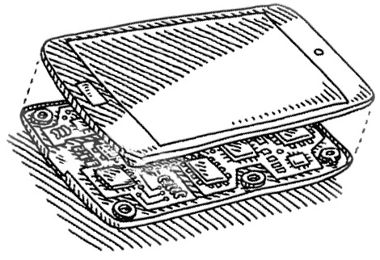

**CAR**

**Computer Architecture**

Logbook **PART 1**

ID: 769535

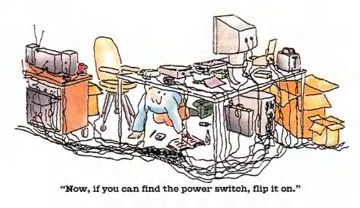Practical Tutor: Ann Plummer

**- Table of Contents -**

Topic: Create a Logbook + Orientation exercise (term 1) 3

My Study Group 4

Topic: Logic exercises, exercises 1 to 5 (term 1) 5

Topic: Logic exercises, exercise 6 (term 1) 10

Topic: Logic exercises, exercises 7 - 9 (term 1) 11

Topic: Logic exercises, exercise 10 (term 1) 14

Topic: Logic exercises, exercise 11 (term 1) 15

Topic: Logic exercises, exercise 12 (term 1) 16

Topic: Create a Cheat Sheet (term 1) 18

Topic: Half Adders (term 1) 20

Topic: Set up Linux / Unix (term 1) 21

Topic: Karnaugh Maps 2-input with worked ex (term 1) 24

Topic: Karnaugh Maps 3-input with worked ex (term 1) 25

Topic: Negative numbers basics (term 1) 26

Topic: Negative numbers more advanced (term 1) 29

Topic: Linux as an operating system (term 1) 31

Topic: Assembler Exercise (term 1) 33

Topic: My Formative Test post mortem (term 1) 35

Bibliography 36

Checklist 37

Topic: Create a Logbook + Orientation exercise (term 1)

1. Add your name/ID to your logbook and **save** it. Done? 

Done

1. Where, in CAR on Moodle, is the receipt sheet?

Coursework🡪Term 1 Coursework🡪Receipt-sheet_CAR_15-16-Term1.docx

1. Add your name/ID to your receipt sheet and print it out. Done?

Done

1. What is the ***minimum*** number of signoffs you need to pass term 1?

4

1. What is the TOTAL ***minimum*** number of signoffs you need to pass?

8

1. What is the shared drive?

The K drive on the network computers which can also be accessed from outside the network

1. Write down how you access the shared drive when off-site

Download and install CoreFTP and connect to the network via the Site Name, Host, Username, Password, Port and Connection of the network

1. Where, in CAR on Moodle, is the scheme of work?

On the main page at the top under coursework

1. Look at the scheme of work (at least the first 5 weeks) – which topics look familiar, which are completely new?

Familiar: Boolean logic, truth tables, logic gates, combinational logic, Unix/Linux, DOS

Un-familiar: Half-Adders, Karnaugh maps, complements

ann.plummer@port.ac.uk

1. Write down Ann's email:
2. Who are your **CAR** practical tutors? (if you have 2, one of them may be me :o)

ann.plummer@port.ac.uk

Ann Plummer

Email:

steve.wilson@port.ac.uk

Steve Wilson

Email:

Now show your work to one of your CAR practical tutors and get your receipt sheet signed. We won't sign any others till we've seen this and signed you off …..

# -My Study Group

Get to know a few people in your CAR practical group. At some point within the first 4 weeks, form a study group. The earlier you do this, the more likely you are to get into a group with people who you can work with.

Don’t just choose friends, choose people who you feel you can form a working relationship with.

No-one likes leeches, so you can eject people from your group who are not pulling their weight. You can also add people (up to a max of 5) or ask to be in a group.

Who is in your study group? Complete below.

Put your name and email FIRST.

You can have up to 5 people in your group.

It works best if they are in the same CAR practical group as you.

If you would like help putting together a study group, please ask your CAR practical tutor.

My Study Group

Matthew Hawkins

up769535@myport.ac.uk

Email:

@myport.ac.uk

Email:

@myport.ac.uk

Email:

@myport.ac.uk

Email:

@myport.ac.uk

Email:

**Now go online and complete the simple form to register your study group. You need to do this even if you have decided to work alone.**

The form is here: <http://goo.gl/forms/bWpd9Z8wEj>

The list of study groups is here: <http://tinyurl.com/CAR-study-groups>

*You can change your study group (add/delete members) whenever you want.*



# Topic: Logic exercises, exercises 1 to 5 (term 1)

How about Logic.ly: <http://logic.ly/demo/>-

Or Logisim: <http://sourceforge.net/projects/circuit/>

( Download: <http://sourceforge.net/projects/circuit/files/latest/download> )

Ex 1: Construct the following:

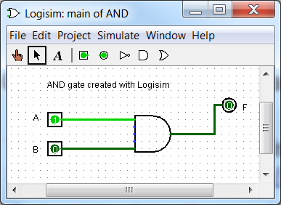

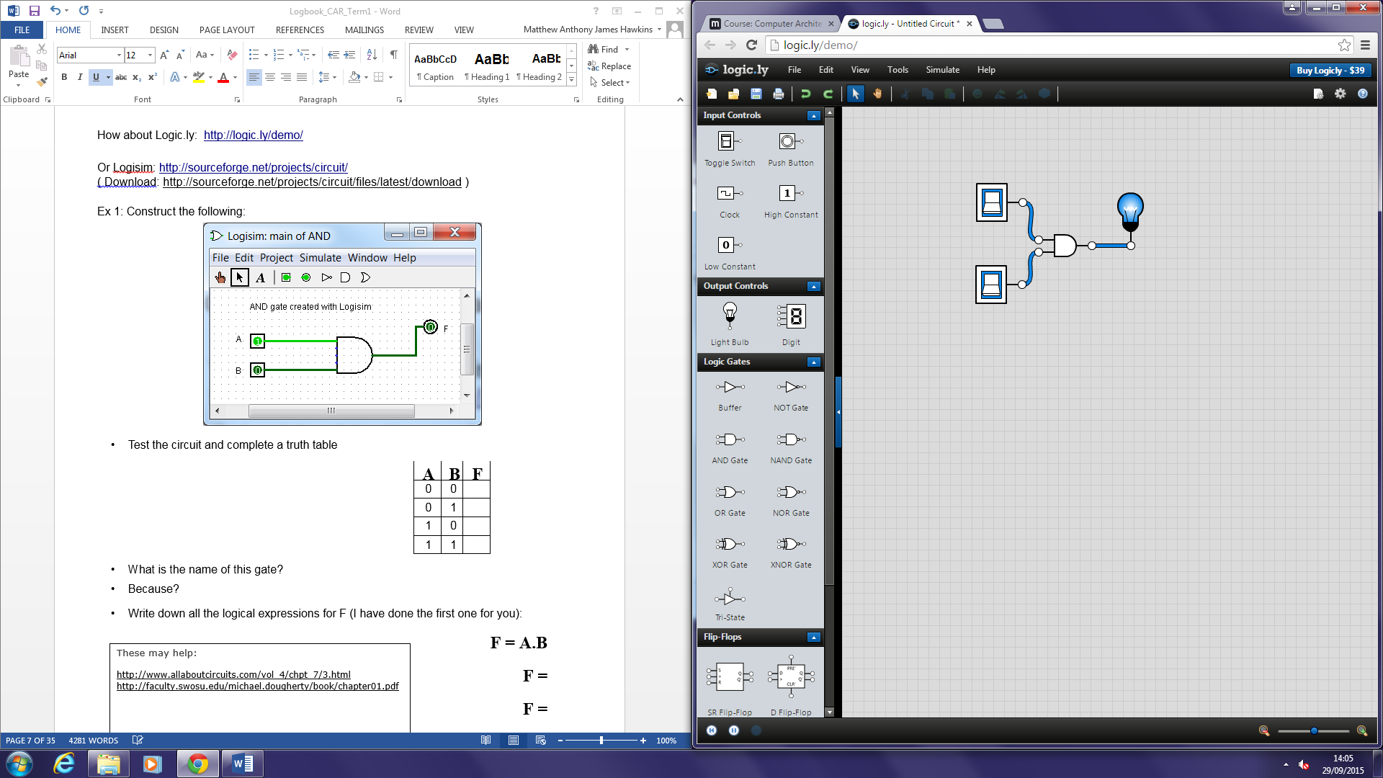

• Test the circuit and complete a truth table

|  |  |  |
| --- | --- | --- |
| **A** | **B** | **F** |
| 0 | 0 | **0** |
| 0 | 1 | **0** |
| 1 | 0 | **0** |
| 1 | 1 | **1** |

• What is the name of this gate? AND Gate

• Because? Switch 1 AND switch 2 have to be on to produce TRUE

• Write down all the logical expressions for F (I have done the first one for you):

**F = A.B**

These may help:

<http://www.allaboutcircuits.com/vol_4/chpt_7/3.html>

<http://faculty.swosu.edu/michael.dougherty/book/chapter01.pdf>

**F = A^B**

**F = AB**

Ex 2: Construct the following using Logic.ly <http://logic.ly/demo/>

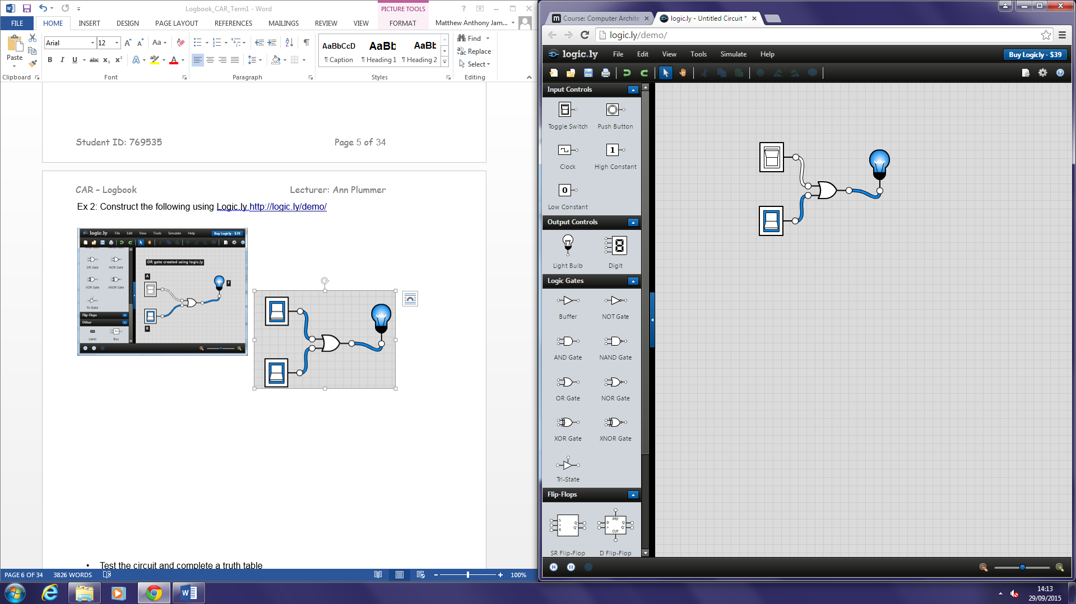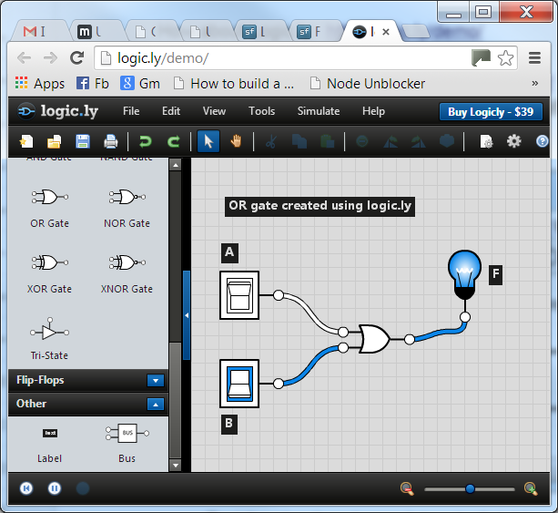

• Test the circuit and complete a truth table

|  |  |  |
| --- | --- | --- |
| **A** | **B** | **F** |
| 0 | 0 | **0** |
| 0 | 1 | **1** |
| 1 | 0 | **1** |
| 1 | 1 | **1** |

• What is the name of this gate? OR Gate

• Because? If switch 1 OR switch 2 OR both are on then the output is TRUE

• Write down all the logical expressions for F:

**F = A+B**

**F = AvB**

This may help: <http://www.bbc.co.uk/schools/gcsebitesize/design/electronics/logicrev2.shtml>

Ex 3: Construct the following:

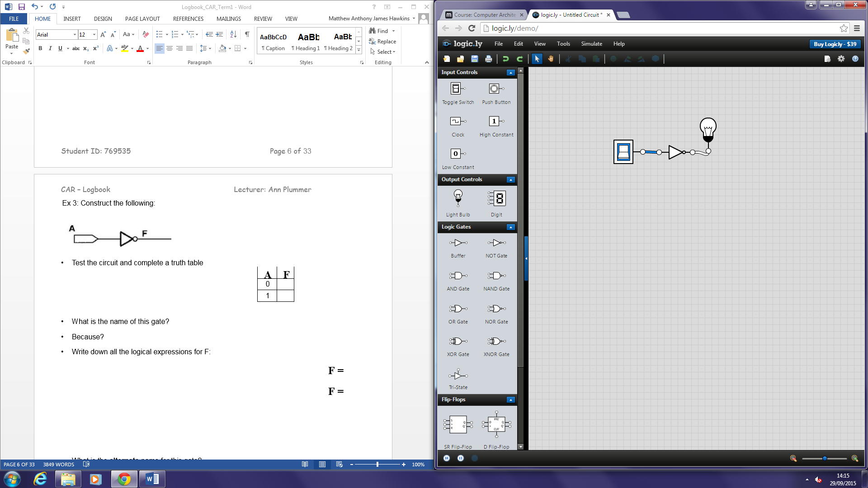

• Test the circuit and complete a truth table

|  |  |
| --- | --- |
| **A** | **F** |
| 0 | **1** |
| 1 | **0** |

• What is the name of this gate? NOT Gate

• Because? The input is reversed so if the switch is on then the output is NOT on

• Write down all the logical expressions for F:

**F = A’**

**F = A**

• What is the **alternate** name for this gate?

Inverter

This may help:

<http://whatis.techtarget.com/definition/logic-gate-AND-OR-XOR-NOT-NAND-NOR-and-XNOR>

Ex 4: Construct the following using a simulator:



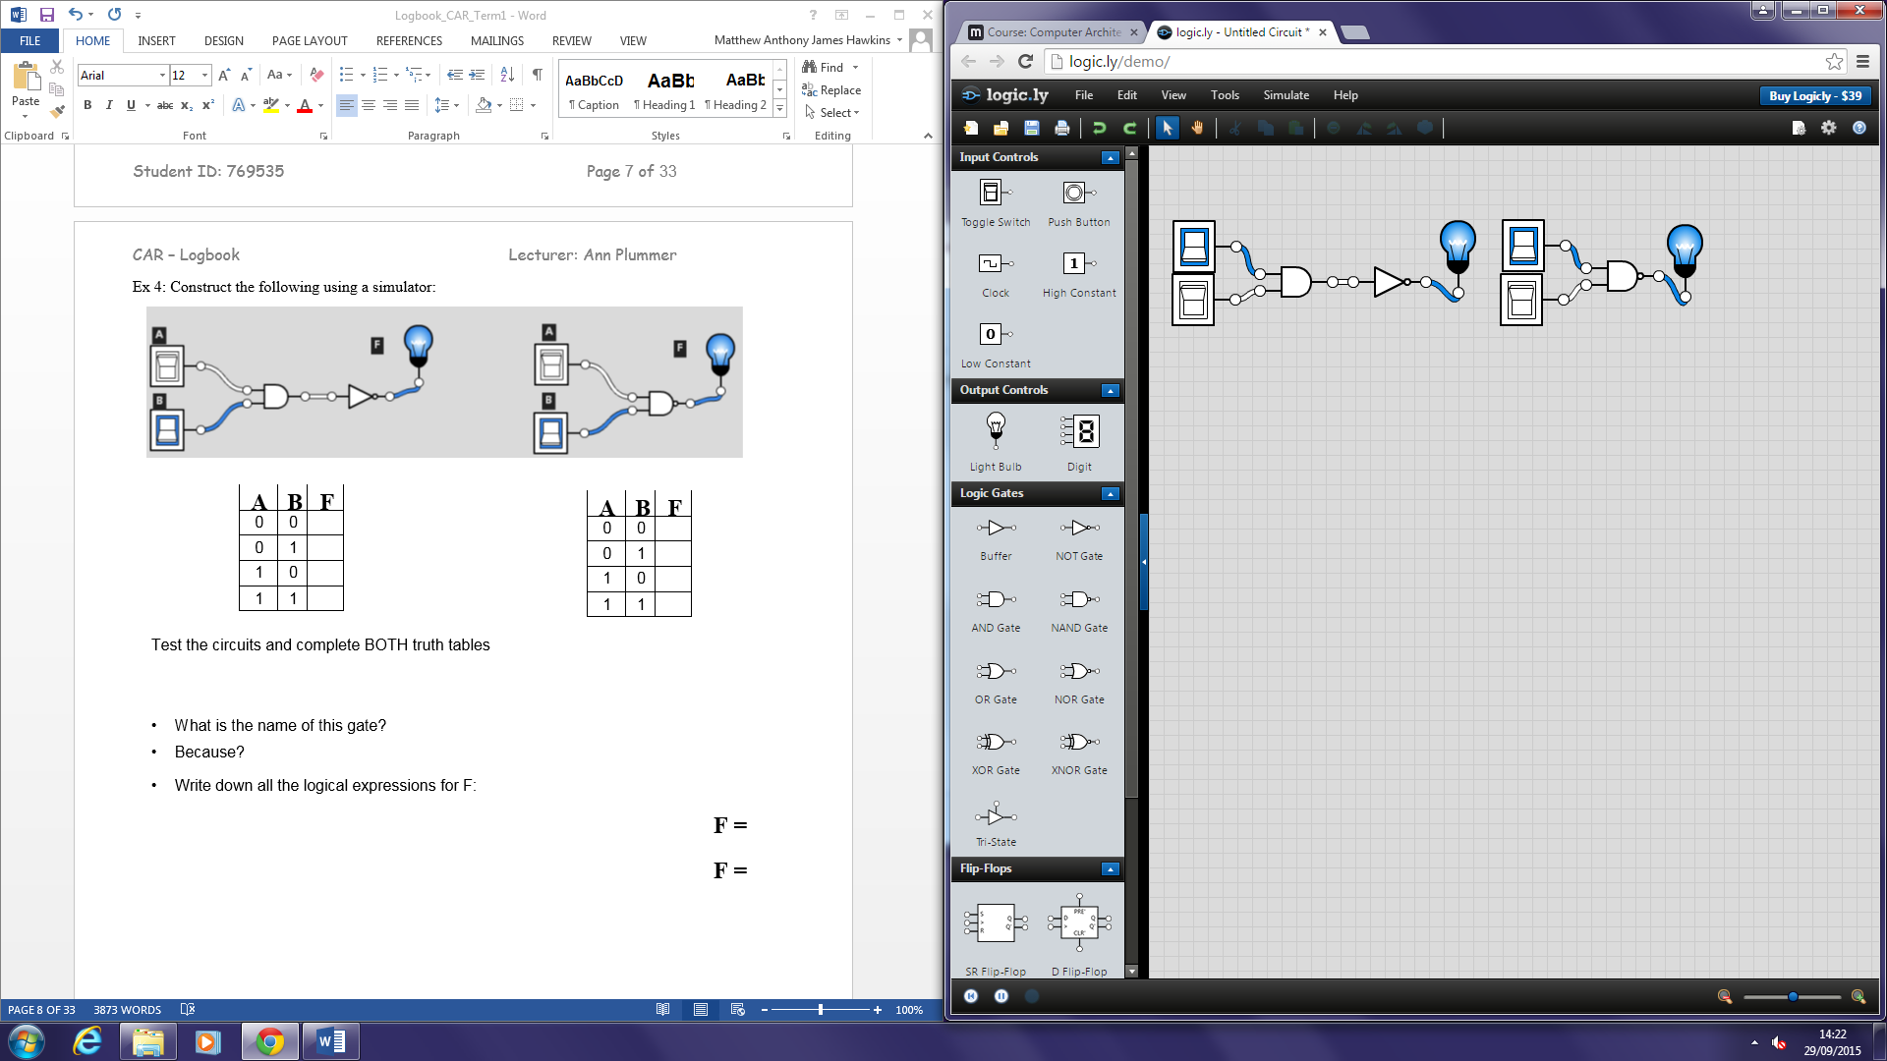

|  |  |  |
| --- | --- | --- |
| **A** | **B** | **F** |
| 0 | 0 | **1** |
| 0 | 1 | **1** |
| 1 | 0 | **1** |
| 1 | 1 | **0** |

|  |  |  |
| --- | --- | --- |
| **A** | **B** | **F** |
| 0 | 0 | **1** |
| 0 | 1 | **1** |
| 1 | 0 | **1** |
| 1 | 1 | **0** |

Test the circuits and complete BOTH truth tables

• What is the name of this gate? NAND Gate

• Because? It is the inverse of AND, therefore NOT AND (NAND)

• Write down all the logical expressions for F:

**F = AB**

**F = A.B**

This may help: <http://www.explainthatstuff.com/logicgates.html>

Ex 5: Construct both of the following using the simulator:



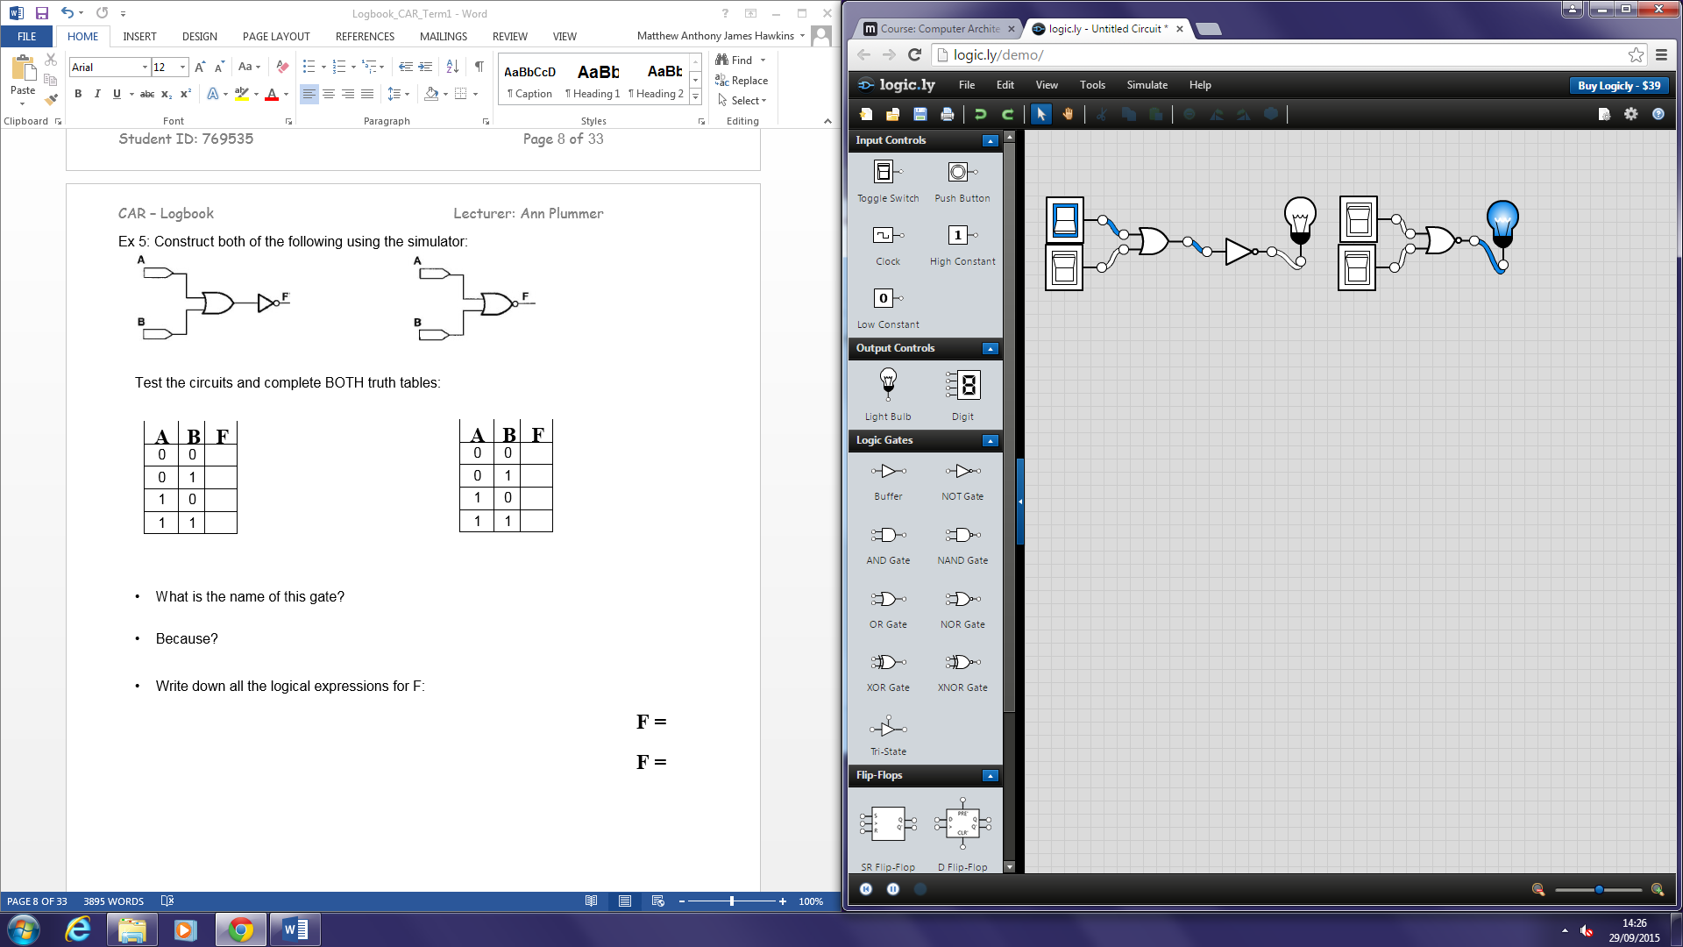

Test the circuits and complete BOTH truth tables:

|  |  |  |
| --- | --- | --- |
| **A** | **B** | **F** |
| 0 | 0 | **1** |
| 0 | 1 | **0** |
| 1 | 0 | **0** |
| 1 | 1 | **0** |

|  |  |  |
| --- | --- | --- |
| **A** | **B** | **F** |
| 0 | 0 | **1** |
| 0 | 1 | **0** |
| 1 | 0 | **0** |
| 1 | 1 | **0** |

• What is the name of this gate? NOR Gate

• Because? It is the inverse of the OR gate, therefore NOT OR (NOR)

• Write down all the logical expressions for F:

**F = A+B**

**F = AvB**

**F= (AvB)’**

This may help: <http://www.electronics-tutorials.ws/logic/logic_6.html>

# Topic: Logic exercises, exercise 6 (term 1)

Ex 6: Construct both of the following using a simulator of your choice:

Test both circuits by completing truth tables for each.



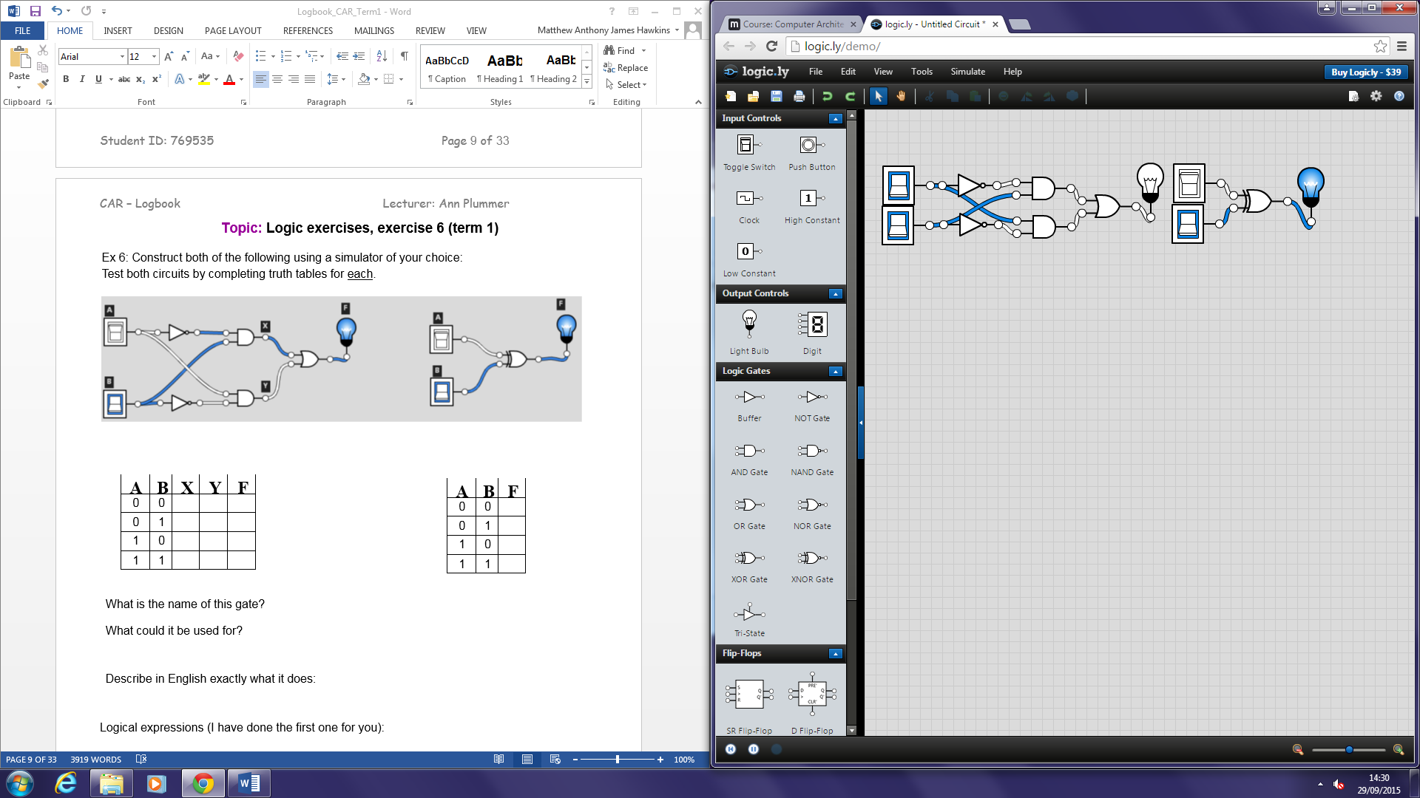

|  |  |  |
| --- | --- | --- |
| **A** | **B** | **F** |
| 0 | 0 | **0** |
| 0 | 1 | **1** |
| 1 | 0 | **1** |
| 1 | 1 | **0** |

|  |  |  |  |  |
| --- | --- | --- | --- | --- |
| **A** | **B** | **X** | **Y** | **F** |
| 0 | 0 | **0** | **0** | **0** |
| 0 | 1 | **1** | **0** | **1** |
| 1 | 0 | **0** | **1** | **1** |
| 1 | 1 | **0** | **0** | **0** |

What is the name of this gate? XOR Gate

What could it be used for? Lighting systems in houses

Describe in English exactly what it does:

If either of the switches is on then the output will be TRUE but if both or none of the switches are on then the output will be FALSE.

Logical expressions (I have done the first one for you):

**_**

**X = A.B Y = A.B**

**F = A.B+A.B**

This may help: <http://logic.ly/lessons/xor-gate/>

# Topic: Logic exercises, exercises 7 - 9 (term 1)

*As you work through exercises 7 to 11, you’ll be covering some*

useful relationships.

*Save yourself time by summarizing them in a ‘cheat sheet’ (further on in this logbook), as you work through the exercises.*

Ex 7: Construct the following using your favourite simulator:

|  |  |
| --- | --- |
| **A** | **F** |
| 0 | **0** |
| 1 | **1** |

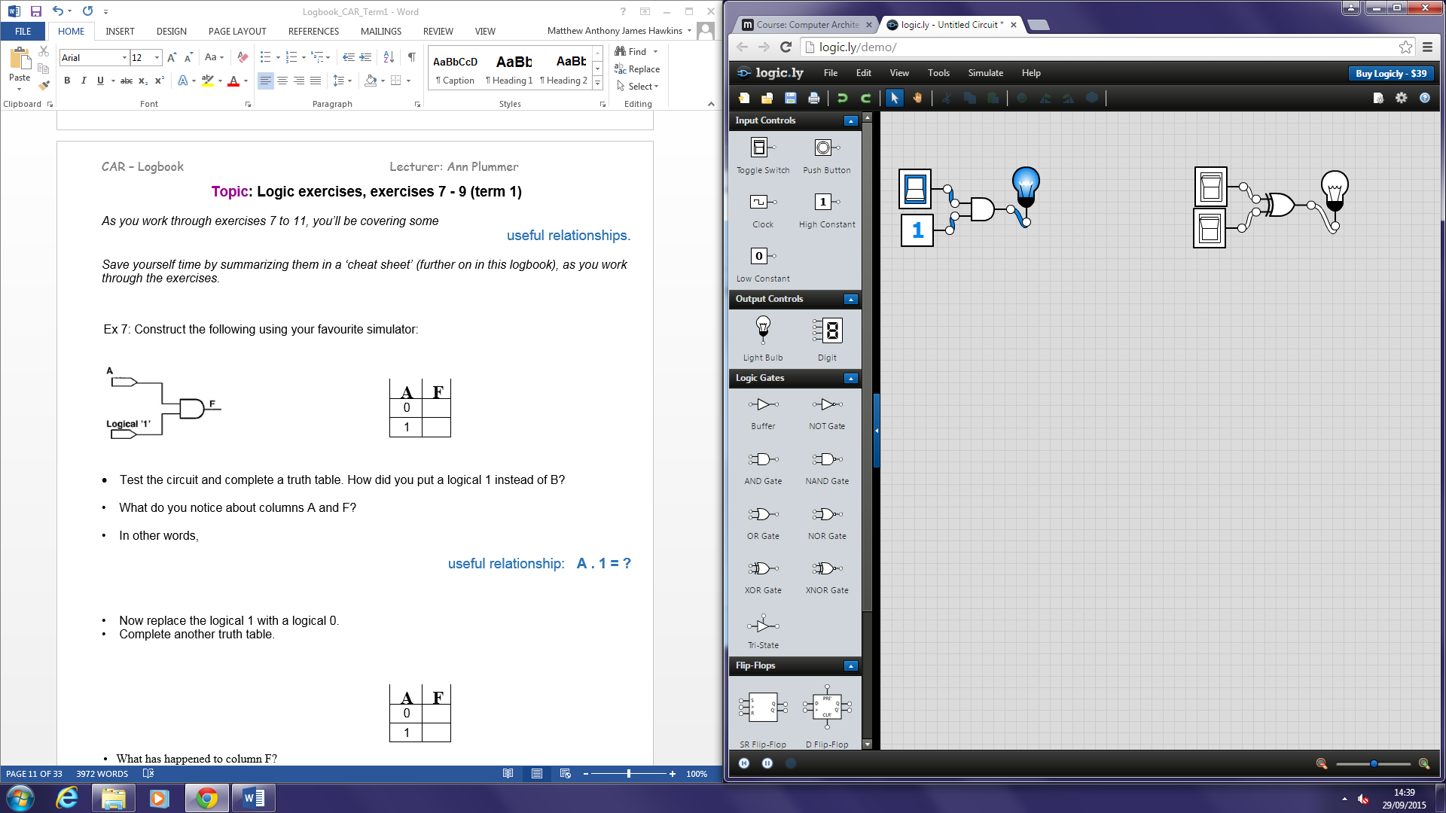

* Test the circuit and complete a truth table. How did you put a logical 1 instead of B? Use the option called “High constant” which gives you then input of 1

• What do you notice about columns A and F? That the output is directly related to the input of A and that both columns are the same

• In other words,

useful relationship: A . 1 = A

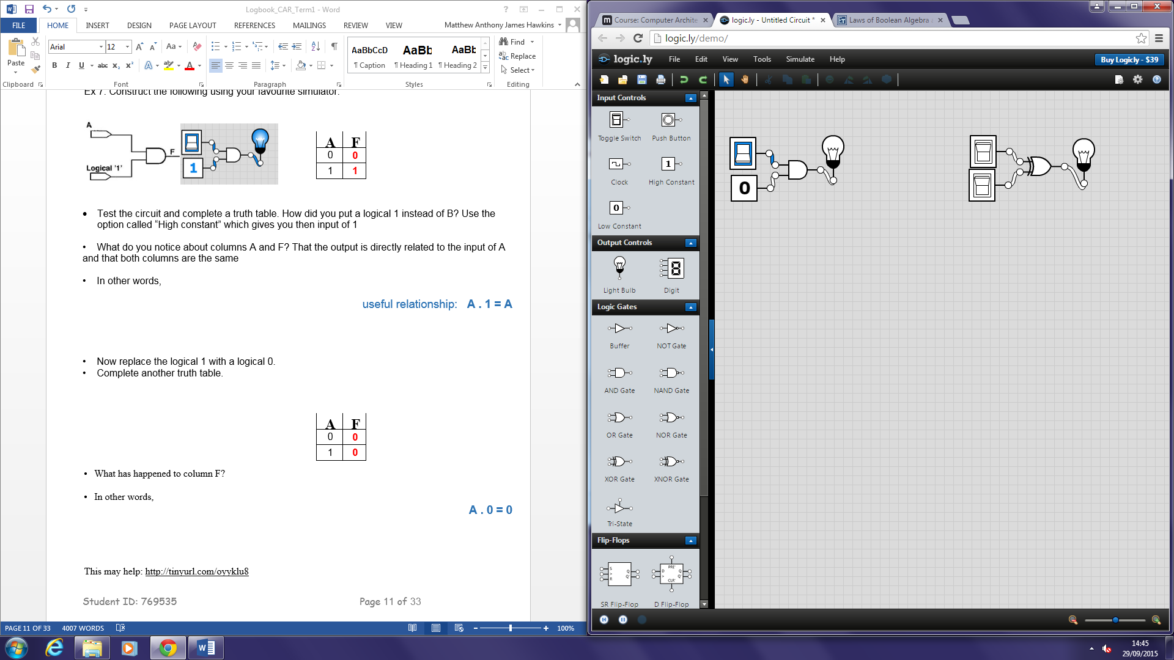

• Now replace the logical 1 with a logical 0.

• Complete another truth table.

|  |  |
| --- | --- |
| **A** | **F** |
| 0 | **0** |
| 1 | **0** |

• What has happened to column F? No matter the input the output will always be 0

• In other words,

A . 0 = 0

This may help: <http://tinyurl.com/oyyklu8>Ex 8: Construct the following:

|  |  |
| --- | --- |
| **A** | **F** |
| 0 | **1** |
| 1 | **1** |

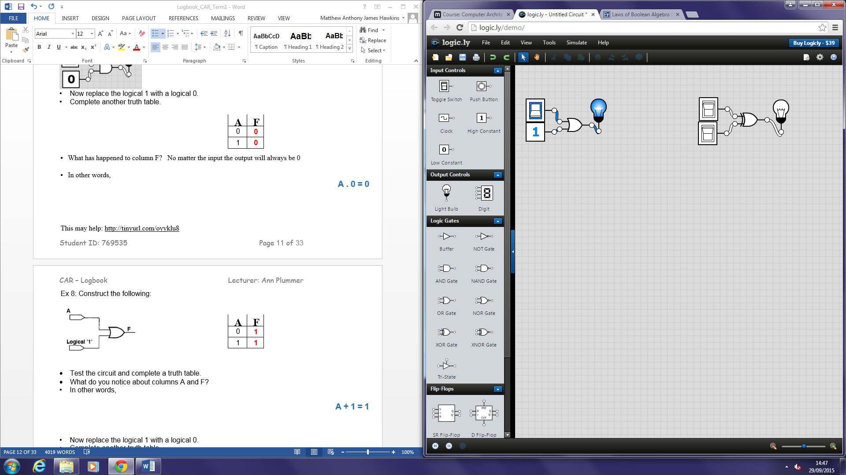

* Test the circuit and complete a truth table.
* What do you notice about columns A and F? F will always produce 1 because it’s an OR gate receiving a logical 1

• In other words,

A + 1 = 1

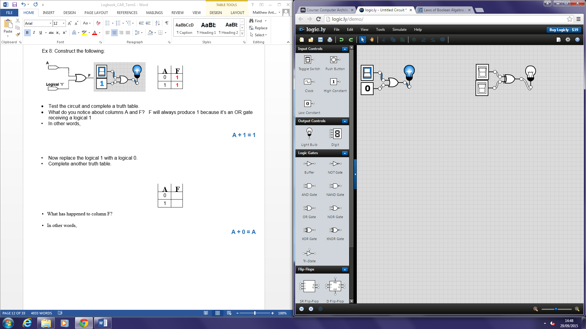

• Now replace the logical 1 with a logical 0.

• Complete another truth table.

|  |  |
| --- | --- |
| **A** | **F** |
| 0 | **0** |
| 1 | **1** |

• What has happened to column F? It is dependant on A as the logical 0 doesn’t give it an input

• In other words,

A + 0 = A

Ex 9: Construct the following 2 circuits:





|  |  |  |
| --- | --- | --- |
| **A** | **A** | **F** |
| 0 | **1** | **0** |
| 1 | **0** | **0** |

__ __

|  |  |  |
| --- | --- | --- |
| **A** | **A** | **F** |
| 0 | **1** | **1** |
| 1 | **0** | **1** |

* Test the circuits and complete their truth tables.

**_**

A ^ A = 0

**_**

A v A = 1

# Topic: Logic exercises, exercise 10 (term 1)

Ex 10: Construct the following:



|  |  |  |
| --- | --- | --- |
| **A** | **B** | **F** |
| 0 | 0 | **0** |
| 0 | 1 | **0** |
| 1 | 0 | **1** |
| 1 | 1 | **1** |

Test the circuit and complete the TT:

We have shown the following useful relationship:

A v AB = A

Using different symbols, write this expression again:

A ＋ AB = A

# Topic: Logic exercises, exercise 11 (term 1)

Ex 11: Construct the following:



|  |  |  |
| --- | --- | --- |
| **A** | **B** | **F** |
| 0 | 0 | **0** |
| 0 | 1 | **1** |
| 1 | 0 | **1** |
| 1 | 1 | **1** |

Test the circuit and complete the TT:

We have shown the following useful relationship:

A v A’B = A + B

Using different symbols, write this expression again:

A + AB = A v B

Compare the TT to the one in ex. 2.

They are the same but this one has a NOT gate

The relationships are important, they will crop up in your exam (guaranteed!), will save you time (see next) and they form part of your ‘cheat sheet’ exercise.

# Topic: Logic exercises, exercise 12 (term 1)

Ex 12:

_

Create this circuit in your simulator: AB + AB + BC

|  |  |  |  |
| --- | --- | --- | --- |
| **A** | **B** | **C** | **F** |
| 0 | 0 | 0 | **0** |
| 0 | 0 | 1 | **0** |
| 0 | 1 | 0 | **1** |
| 0 | 1 | 1 | **1** |
| 1 | 0 | 0 | **0** |
| 1 | 0 | 1 | **0** |
| 1 | 1 | 0 | **1** |
| 1 | 1 | 1 | **1** |

Test it, complete a TT here:

Screenshot your circuit here:

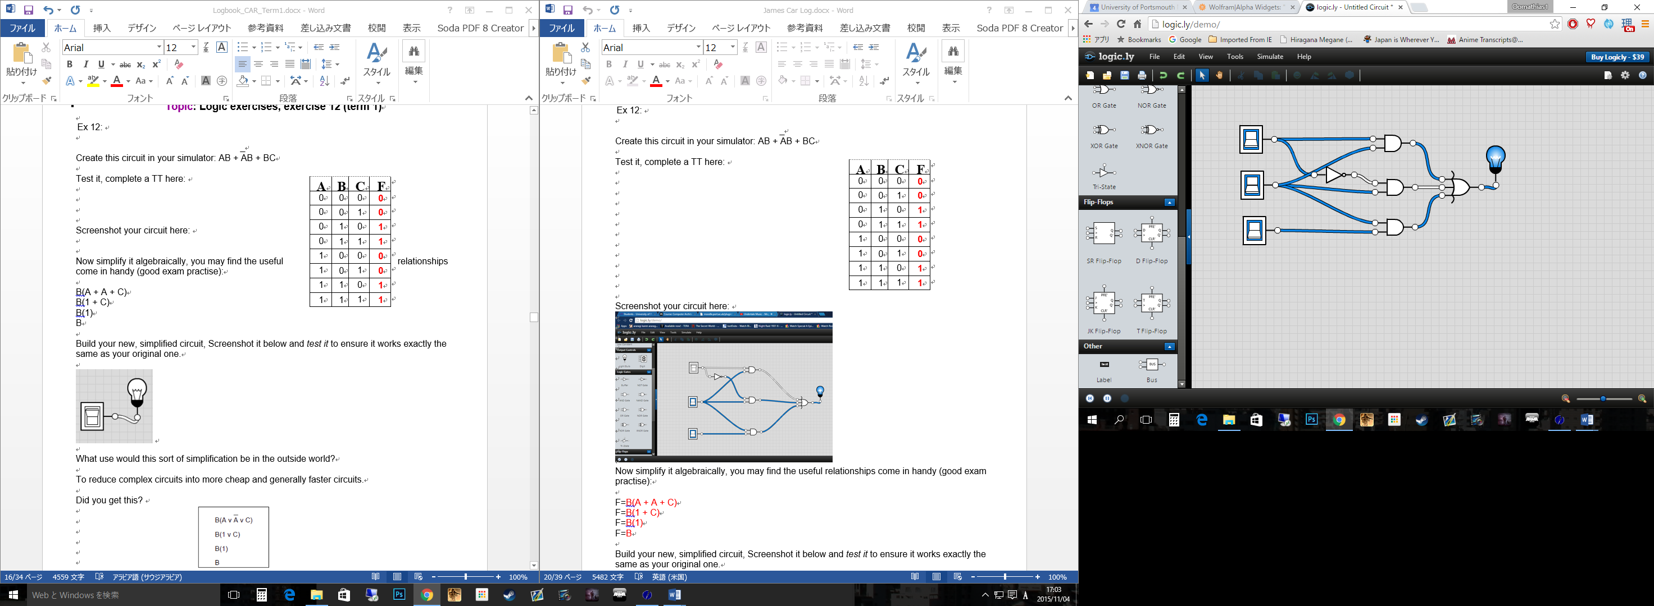

Now simplify it algebraically, you may find the useful relationships come in handy (good exam practise):

B(A + A + C)

B(1 + C)

B(1)

B

Build your new, simplified circuit, Screenshot it below and *test it* to ensure it works exactly the same as your original one.

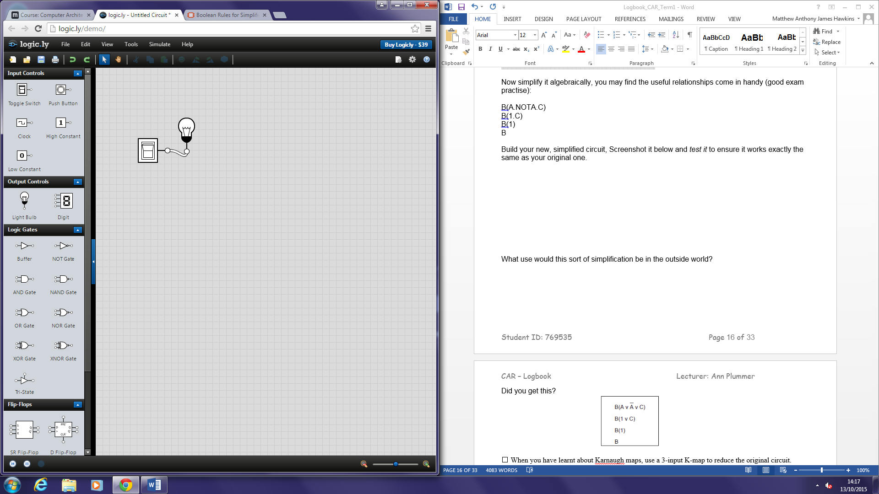

What use would this sort of simplification be in the outside world?

To reduce complex circuits into more cheap and generally faster circuits.

Did you get this?

⇧ When you have learnt about Karnaugh maps, use a 3-input K-map to reduce the original circuit.

AB + AB + BC

|  |  |  |  |  |  |  |
| --- | --- | --- | --- | --- | --- | --- |
|  | AB | **00** | **01** | | **11** | **10** |
| C | **1** | ０ | | 1 | 1 | ０ |
|  | **0** | ０ | | 1 | 1 | ０ |

Minimised function:

The only thing that remains constant is B so the minimised function is B = B

⇧ Are your results the same?

Yes

# Topic: Create a Cheat Sheet (term 1)

***I would recommend covering this exercise very thoroughly, as it will save you hours of work when you start your revision.***

* Make a table in a word processor (or by hand)
* Summarize every digital gate, its diagram, its common formulae, its functionality

e.g. AND A.B A^B AB

'to get a 1 out, all inputs must be 1'

* Summarize the useful relationships.

|  |  |  |  |
| --- | --- | --- | --- |
| Gate | Diagram | Formulae | Functionality |
| AND |  | A.B, A^B, AB | When both inputs are 1 then the output will be 1 |
| OR |  | A+B, AvB, | When one or the other or both inputs are 1 then the output will be 1 |
| NOT |  | NOT, | Inverts the input |
| NAND |  | A.B, A^B, AB | It is the inverse of the AND gate. It will output a 0 when both inputs are 1. Otherwise all outputs are 1. |
| NOR |  | A+B, AvB | It is the inverse of the OR gate. It will output 1 if both inputs are 0. Otherwise all outputs are 0. |
| XOR |  | A(+)B | The output will be 1 when either input is 1 but no when both are 1, like a normal OR gate would. |
| XNOR |  | A(+)B | It is the inverse of the XOR gate. It will give a 0 output if either, but not both, inputs are 1. |

**Truth Tables**

|  |  |  |  |  |  |  |  |  |
| --- | --- | --- | --- | --- | --- | --- | --- | --- |
| A | B | AND | OR | XOR | NOT | NOR | NAND | XNOR |
| 0 | **0** | **0** | **0** | **0** | **1** | **1** | **1** | **0** |
| 0 | **1** | **0** | **1** | **1** |  | **0** | **1** | **1** |
| 1 | **0** | **0** | **1** | **1** | **0** | **0** | **1** | **1** |
| 1 | **1** | **1** | **1** | **0** |  | **0** | **0** | **0** |

**Useful Relationships**

A + 1 = 1 Annulment

A + 0 = A Identity

A . 1 = A Identity

A . 0 = 0 Annulment

A + A = A Idempotent

A . A = A Idempotent

NOT A = A Double Negation

A + A = 1 Complement

A + B = B + A Commutative

A . B = B . A Commutative

A+B = A.B de Morgan’s Theorem

A.B = A+B de Morgan’s Theorem

# Topic: Half Adders (term 1)

* Using the learning materials, books and Internet resources, research and read around **HALF ADDERS**.
* Build a half adder in <http://logic.ly/demo> and screenshot it here. See week 3 lecture for more info.

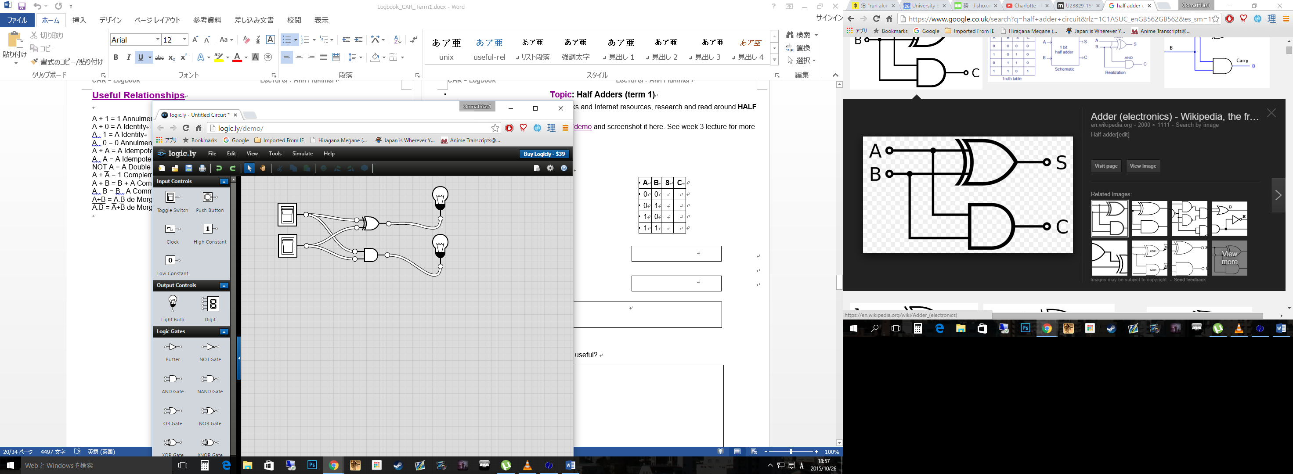

* Test it and complete a truth table:

|  |  |  |  |
| --- | --- | --- | --- |
| **A** | **B** | **S** | **C** |
| 0 | 0 | 0 | 0 |
| 0 | 1 | 1 | 0 |
| 1 | 0 | 1 | 0 |
| 1 | 1 | 0 | 1 |

* Now write the functions

C = A.B

S =

S = A XOR B

C =

Not that useful as it only adds 1 bit

* How useful is a half adder

on its own?

* What is it lacking to make it really useful?

Another half adder. If you add two half adders together you get a full adder which can allow a full addition.

This may help: <https://www.youtube.com/watch?v=QbhI5OrpbHc>

# Topic: Set up Linux / Unix (term 1)

You may use just about any version of Unix/Linux, as long as you can access the command line (may be called Terminal)

Mac users will already have a version on their machines.

Have you tried the dual-boot into Linux in the labs? Make notes here:

Have you downloaded a roaming version of Linux (eg Damn Small Linux – DSL) to use from your usb?

Some links which may be useful:

<http://www.slax.org/>   
<http://puppylinux.org/main/How%20to%20download%20Puppy.htm>  
<http://www.porteus.org/>  
<http://www.softpedia.com/get/System/System-Miscellaneous/Tiny-Core-Linux-USB-installer.shtm>

Or have you downloaded and created a live disk of a version of Linux? (Ubuntu is nice) or have you got hold of Linux some other way (eg some of you, particularly Mac folk, will have Linux on your machine already)?

What do you think of the various versions?

Show **at least 3 screenshots** of you trying out different sorts of Linux/Unix. You should include **your full name** somewhere on each screenshot.

**Screenshot 1: Execute bash shell online**

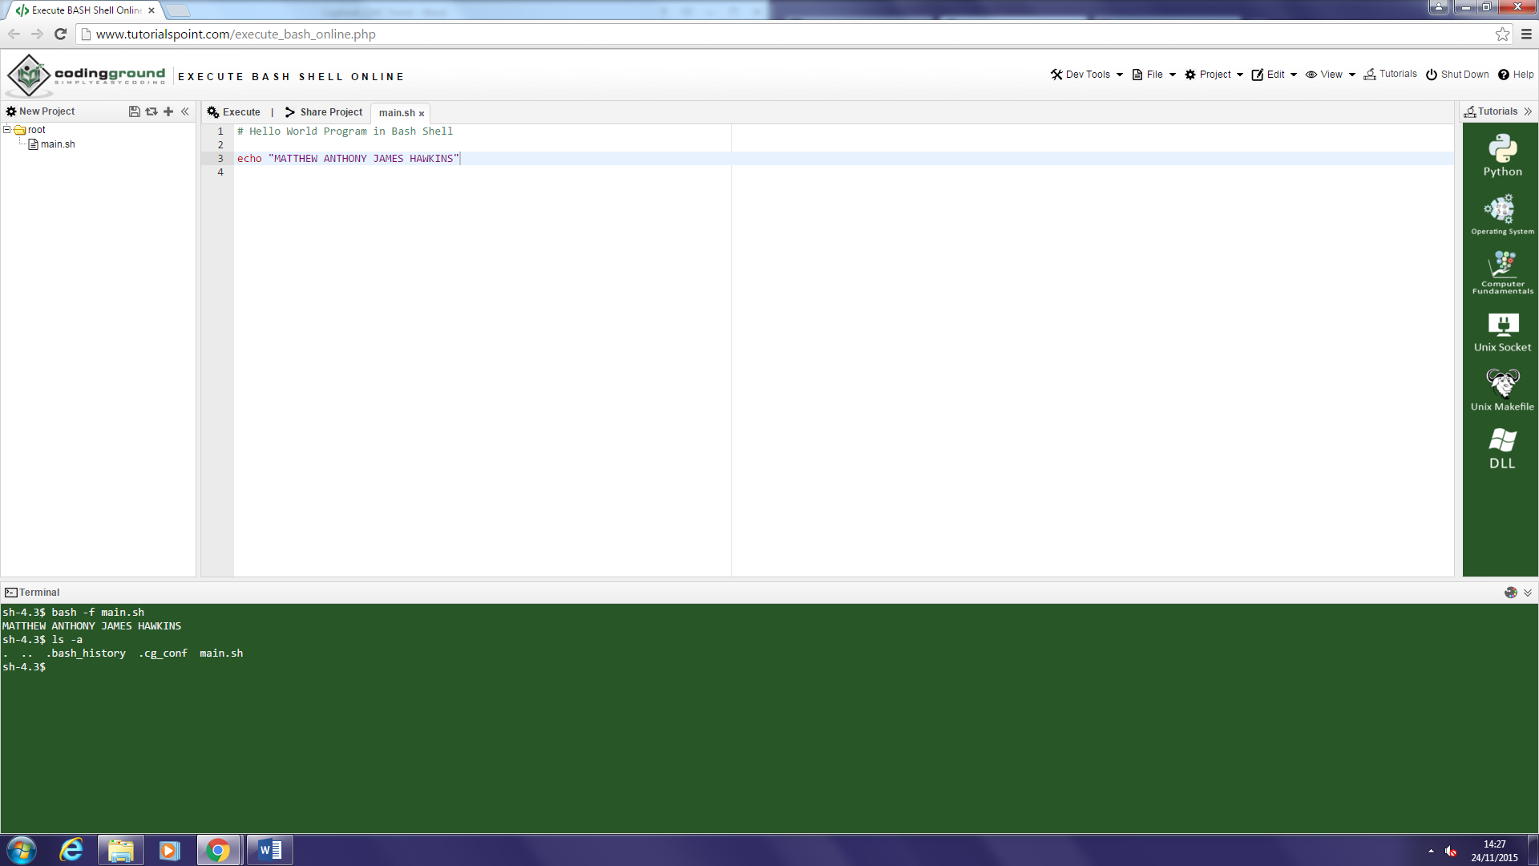

**Screenshot 2: Ubuntu Terminal**

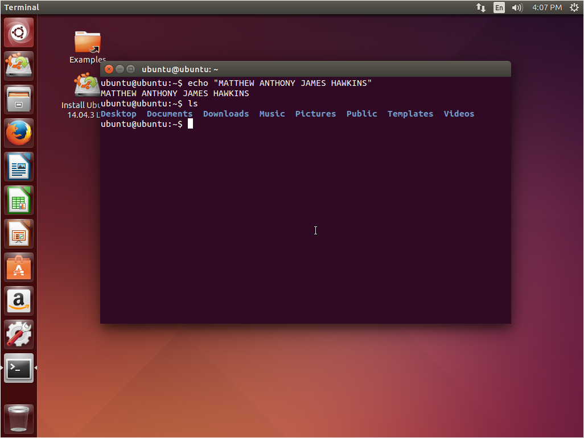

**Screenshot 3: Linux Mint 13 “Maya” – Cinnamon Terminal**

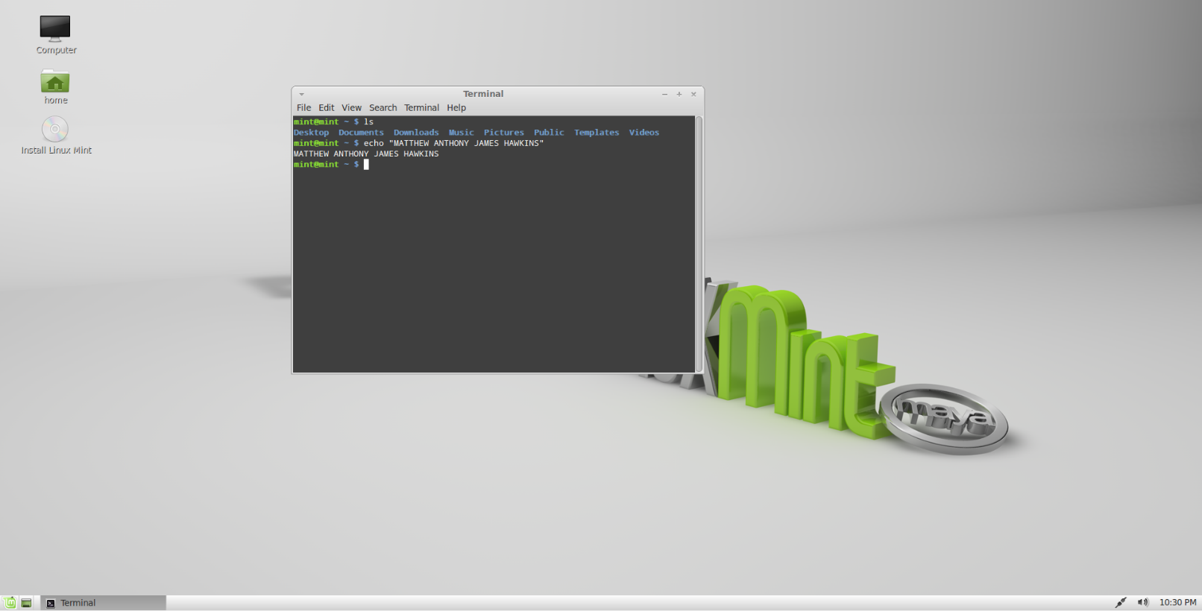

# Topic: Karnaugh Maps 2-input with worked ex (term 1)

For some people, this is not the easiest subject in the world. If you feel you may get lost with Karnaugh maps, cover them thoroughly in your logbook!

Ask for help in the practical sessions, just to make sure you are on the right track.

* How do you work out how many cells you need in a Karnaugh map?

You look at the amount of inputs you have. E.g. A and B will be a 2x2 map

* What is Gray code and why do we use it in a Karnaugh map?

A numerical code where numbers are represented by binary numbers that differ by only one digit at a time, we use this for the cell coordinates of a k map

* Create a circuit in Logic.ly/demo with 2 inputs, A and B; output F. Have at least 4 gates + 1 NOT gate in your circuit. Screenshot it here:

|  |  |  |
| --- | --- | --- |
| **A** | **B** | **F** |
| 0 | 0 | 1 |
| 0 | 1 | 0 |
| 1 | 0 | 1 |
| 1 | 1 | 0 |

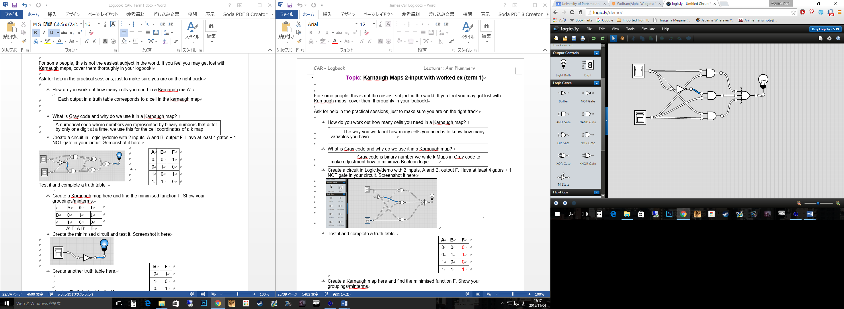

Test it and complete a truth table:

* Create a Karnaugh map here and find the minimised function F. Show your groupings/minterms.

|  |  |  |  |  |
| --- | --- | --- | --- | --- |
|  | A | **0** | **1** | |
| B | **0** | 1 | | 1 |
|  | **1** | 0 | | 0 |

A’.B’.A.B’ = B’

* Create the minimised circuit and test it. Screenshot it here:

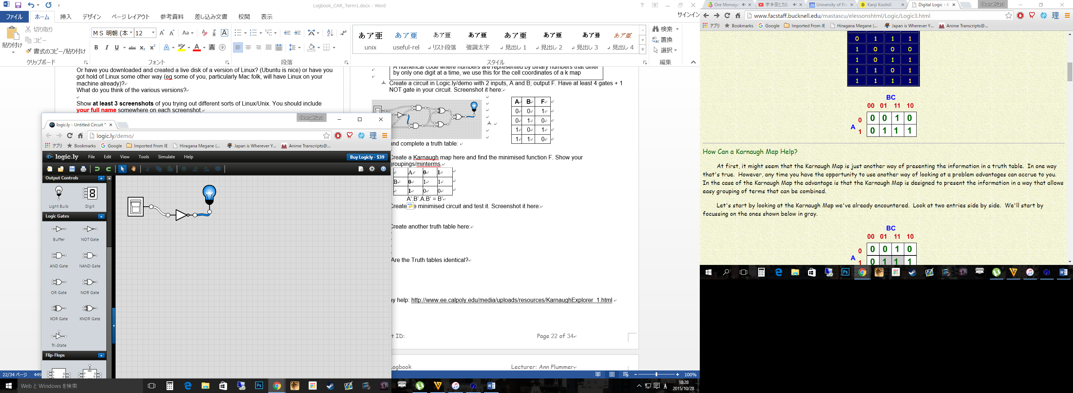

|  |  |
| --- | --- |
| **B** | **F** |
| 0 | 1 |
| 1 | 0 |

* Create another truth table here:
* Are the Truth tables identical?

We have no need for A, as it is redundant, so the truth table changes because of this. Other than that the B column is exactly the same as expected.

This may help: <http://www.ee.calpoly.edu/media/uploads/resources/KarnaughExplorer_1.html>

# Topic: Karnaugh Maps 3-input with worked ex (term 1)

* Create a circuit in Logic.ly/demo with 3 inputs, A, B, C; output F. Have at least 4 gates + 1 NOT gate in your circuit. Screenshot it here:

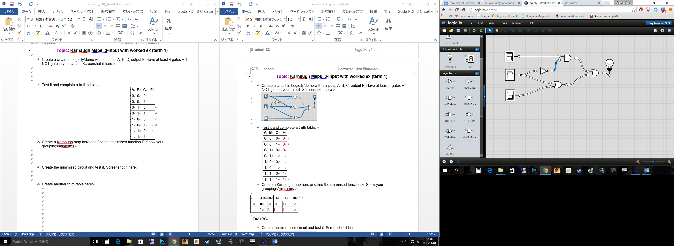

|  |  |  |  |
| --- | --- | --- | --- |
| **A** | **B** | **C** | **F** |
| 0 | 0 | 0 | 0 |
| 0 | 0 | 1 | 1 |
| 0 | 1 | 0 | 1 |
| 0 | 1 | 1 | 1 |
| 1 | 0 | 0 | 1 |
| 1 | 0 | 1 | 1 |
| 1 | 1 | 0 | 1 |
| 1 | 1 | 1 | 1 |

* Test it and complete a truth table:
* Create a Karnaugh map here and find the minimised function F. Show your groupings/minterms.

|  |  |  |  |  |  |  |  |
| --- | --- | --- | --- | --- | --- | --- | --- |
|  | AB | **00** | **01** | | **11** | | **10** |
| C | **0** | 0 | 1 | 1 | | 1 | |
|  | **1** | 1 | 1 | 1 | | 1 | |

Large right group = ABC’ AB’C’ ABC AB’C

Simplifies to = A

Large left group (overlaps with right group) = A’BC’ A’BC ABC’ ABC

Simplifies to = B

Single left group = A’B’C

Simplifies to = C

Minimised function = A + B + C

* Create the minimised circuit and test it. Screenshot it here:

|  |  |  |  |
| --- | --- | --- | --- |
| **A** | **B** | **C** | **F** |
| 0 | 0 | 0 | 0 |
| 0 | 0 | 1 | 1 |
| 0 | 1 | 0 | 1 |
| 0 | 1 | 1 | 1 |
| 1 | 0 | 0 | 1 |
| 1 | 0 | 1 | 1 |
| 1 | 1 | 0 | 1 |
| 1 | 1 | 1 | 1 |

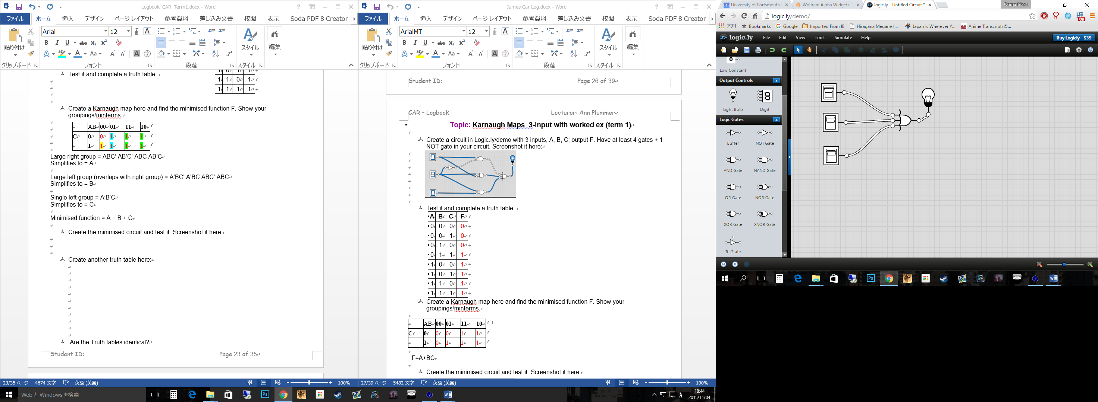

* Create another truth table here:
* Are the Truth tables identical?

Yes

# Topic: Negative numbers basics (term 1)

**Example 1**

What is the decimal integer value of **0101 1001** stored in a **byte** if the representation is: **2's complement** form? Show your working.

Find the closest 1 to the right then flip all digits to the left of that digit, in this case all the values are flipped besides the first 1

10100111

Check:

01011001 = 89

10100111 = -89

**Example 2**

Store these integers in bytes using the 2's complement notation:

Show your working.

1. + 36 00100100

b) +130 Can’t be done in 8 bits

Worked ex Method **1**:

Store **-**24 in a byte using 2's complement notation.

Steps 1 and 2 determine the 1's complement:

Step 1: +24 in binary is 0001 1000.

Step 2: Invert bits to yield 1110 0111. Then the 1's complement of -27 is 1110 0111.

Step 3 is the additional step needed to find the 2's complement.

Step 3: Add 1 to the 1's complement:

1110 0111

+ 1

1110 1000

-24 in 2's complement is 1110 1000.

Worked ex Method **2**:

Store **-**24 in a byte using 2's complement notation.

Step 1: +24 in binary is 0001 1000.

Step 2: Start from right, copy all bits up to and *including* the first ‘1’: 0001 **1000**

Step 3: Invert all the other bits: **1110** 1000

-24 in 2's complement is 1110 1000.

**Example 3a**

Using Method 1:

Store the integer -70 in a byte using the two's complement notation.

Show your working in the table that follows:

|  |  |  |
| --- | --- | --- |
| Step | Procedure | Binary Answer in Byte Form |
| 1 | Write +70 in binary | 01000110 |
| 2 | Take the one's complement (invert the contents of the byte) | 10111001 |
| 3 | Add 1 to the LSB | 1 |
|  | The answer is the two's complement version of -70. | 10111010 |
|  | | |

**Example 3b**

Using Method 2:

Store the integer -70 in a byte using the two's complement notation.

Show your working in the table that follows:

|  |  |  |
| --- | --- | --- |
| Step | Procedure | Binary Answer in Byte Form |
| 1 | Write +70 in binary | 01000110 |
| 2 | Start from right, copy all bits up to and *including* the first ‘1’ | 10 |
| 3 | Invert all the other bits | 101110 |
|  | The answer is the two's complement version of -70. | 10111010 |
|  | | |

**Example 4**

Store the following in bytes in 2's complement form. Use whichever method you choose, but clearly show your working:

1. -26

+26 in binary is 00011010, keep bits from the first 1 and invert to 11100110

1. -67

+67 in binary is 01000011, keep bits from the first 1 and invert to 10111101

1. -1

+1 in binary is 00000001, keep bits from the first 1 and invert to 11111111

**Example 5**

a) Explain *in your own words*, how you can tell if a byte in 2's complement form, is positive or negative?

In normal binary each digit represents 128, 64, 32, 16, 8, 4, 2, 1 for one byte. In 2’s compliment the left most bit is a negative so the digits change to -128, 64, 32, 16, 8, 4, 2, 1. Essentially if the left most bit is a 1 in 2’s compliment then the number is negative.

b) Give an example of both a positive and a negative number in 2's complement to illustrate. Select new numbers we haven't used in this worksheet.

+ve ex: 99

01100011

-ve ex: 99

10011101

**Example 6**

Determine the integer decimal equivalent of the following byte-sized 2's complement numbers:

1. 1110 0001

-31

1. 1011 1011

-69

1. 1000 0000

-128

1. 1111 1110

-2

**Example 7**

Write the 16 different 2's complement representations of decimal integers that can be stored in a nibble and their corresponding decimal integer values.

|  |  |
| --- | --- |
| 2's Complement Representation | Decimal Integer |
| 0000 | 0 |
| 0001 | +1 |
| 0010 | +2 |
| 0011 | +3 |
| 0100 | +4 |
| 0101 | +5 |
| 0110 | +6 |
| 0111 | +7 |
| 1000 | -8 |
| 1001 | -7 |
| 1010 | -6 |
| 1011 | -5 |
| 1100 | -4 |
| 1101 | -3 |
| 1110 | -2 |
| 1111 | -1 |

This may help: <http://www.allaboutcircuits.com/textbook/digital/chpt-2/negative-binary-numbers/>

# Topic: Negative numbers more advanced (term 1)

Complete these in your logbook and get them signed off on your receipt sheet.

**Show your working** to get signed off by your tutor. Be prepared to answer questions.

**Example 1**

Complete the following table:

|  |  |  |  |  |
| --- | --- | --- | --- | --- |
| A byte contains the following bits | What decimal integer is stored in the byte for each of the following representations: | | | |
| True binary |  | 1's Complement | 2's Complement |
| a) 0111 0101 | 117 |  | 10001010 | 10001011 |
| b) 1001 1100 | 156 |  | 01100011 | 01100100 |
| c) 0101 0111 | 87 |  | 10101000 | 10101001 |
| d) 1111 1111 | 255 |  | 00000000 | 00000001 |

**Example 2**

1. Store +6 in 2's complement form using **4 bits**.

0110

1. Store -8 in 2's complement form using 4 bits.

1000

1. Store -9 in 2's complement form using 4 bits.

You can’t store -9 in 4 bits in 2’s compliment

**Example 3**

1. What is the *highest* possible positive number you can store in **2** bytes using the 2's complement system?

32767

1. What is the *lowest* possible negative number you can store in **2** bytes using the 2's complement system?

-32768

**Example 4**

Working in **1** byte and 2's complement, work out the following sums and answer the following for each:

1. Work out each number in 2's complement, then
2. Perform the calculation on the 2’s complement numbers.
3. Give the result.
4. Comment on the result – eg was it as expected? If not, why not?

a) 64 + 63 = 0111 1111

1. Work out 64 and 63 in 2's complement: 0100 0000, 0011 1111
2. Perform the calculation on the 2’s complement numbers: 1 + 0 = 1, so in this case the two numbers just combine together
3. Give the result: 0111 1111
4. Comment on the result – eg was it as expected? If not, why not?

It seems just as expected, 64 + 63 = 127 and the two binary forms of these added together produce 127

b) 64 + 64 = 1000 0000

1. 0100 0000, 0100 0000
2. 1 + 1 = 0 carry 1 so,
3. 1000 0000
4. Yes and no, obviously 64 + 64 is +128 but because 2’s compliment makes the first left bit negative the answer is now -128

c) 64 - 64 = (1) 0000 0000

1. Work out 64 and **-**64 in 2's complement: 0100 0000, 1100 0000
2. 1 + 1 = 0 carry 1 so,
3. (1) 0000 0000
4. The bit carries over but because we are only store in 1 byte we can’t store it. Therefore in 1 byte 2’s compliment 64 – 64 = 0

d) 64 – 128 = 1100 0000

1. 0100 0000, 1000 0000
2. 1 + 0 = 1 so,
3. 1100 0000
4. Just as expected, the left most bit is negative so -128 + 64 = -64

e) 0 – 133 = 1010 0001

1. 0000 0000, 1010 0001
2. 1 + 0 = 1 so,
3. 1010 0001
4. As expected 0 + -133 is still -133

**Example 5**

Working with **2** bytes and 2's complement, redo the following examples:

a) 64 + 63 = 0000 0000 0111 1111

1. 0000 0000 0100 0000, 0000 0000 0011 1111
2. 1 + 0 = 1 so,
3. 0000 0000 0111 1111
4. As expected, the extra byte has no effect on the value.

b) 64 + 64 = 0000 0000 1000 0000

1. 0000 0000 0100 0000, 0000 0000 0100 0000
2. 1 + 1 = 0 carry 1 so,
3. 0000 0000 1000 0000
4. As compared to the one byte version the real value of +128 is stored. This is because the left most bit is a 0.

c) 64 - 64 = 0000000000000000

1. 0000 0000 0100 0000, 1111 1111 1100 0000
2. 1 + 1 = 0 carry 1 so,
3. (1) 0000 0000 0000 0000
4. In this case, the extra bit is still carried over to the next byte so we end up with zero

d) 64 – 128 = 1111 1111 1100 0000

1. 0000 0000 0100 0000, 0000 0000 1000 0000
2. 1 + 0 = 1 so,
3. 1111 1111 1100 0000
4. In this case we get -64 which is to be expected

# Topic: Linux as an operating system (term 1)

This exercise looks very long (well, it *is* very long :o), but it’s very simple and fast and is absolutely essential to work through, to get you familiar with the basics.

Just follow through the examples, *trying things out* and *making notes* as you go along (like everything else in your logbook, it is also revision for your exam!)

[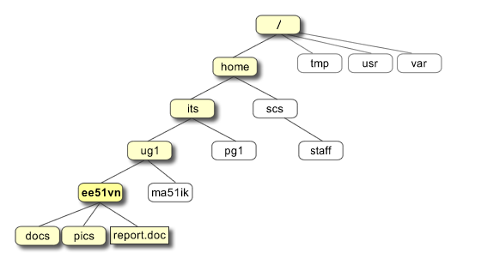](http://www.ee.surrey.ac.uk/Teaching/Unix/unixintro.html) <http://www.ee.surrey.ac.uk/Teaching/Unix/unixintro.html>

***Note*** *There are many variations of Unix/Linux, so if you should find a command option behaving differently on your local machine you should consult the on-line manual page for that command. Some commands have numerous options, so for fuller information on these commands use the relevant on-line manual page.*

Using the Unix on-line manual pages

Unix comes with a complete manual which provides guidance on using the language. To use the manual you need to know the name of the command you wish to investigate.

a) At the unix prompt type ls (‘list’) - This command lists the contents of a directory, assuming you want a list for the pwd (present working directory) if no path is stated.

b) Now explore the manual entry for this command by typing man ls

c) What kind of info is the SYNOPSIS section of the manual page giving you?

It gives the syntax, in the case of ls it gives: ls [-CFRacdilqrtu1][-H | -L ][-fgmnopsx][file...]

d) Are there ways of using the ls command that change the information provided?

There are a variety of options that you can use such as -C, -F, -H, -L etc.

e) Try ls -l and ls –a

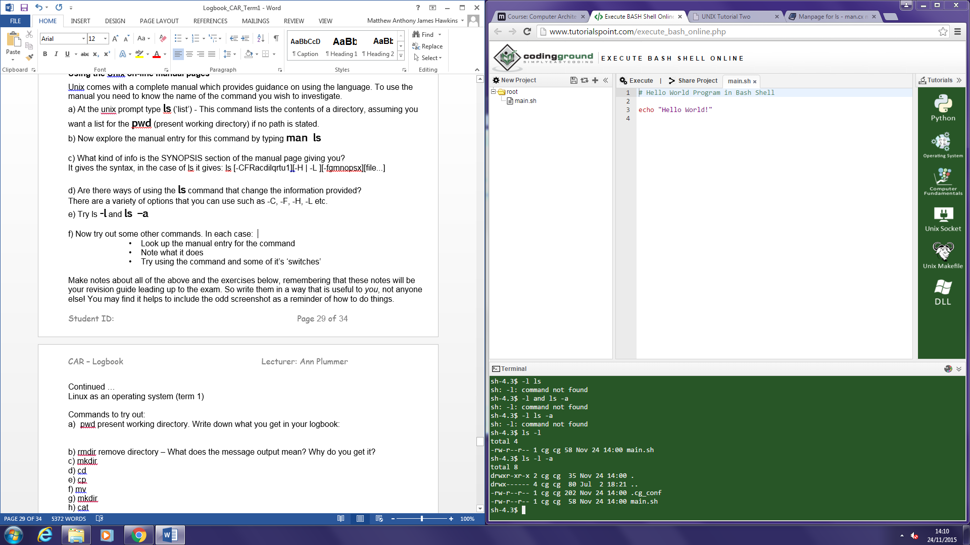

f) Now try out some other commands. In each case:

* + Look up the manual entry for the command
  + Note what it does
  + Try using the command and some of it’s ‘switches’`

cp

cp [-fip] source_file target_file

copies a file to another location, it keeps the original file as well.

mv

mv [-fi] source_file target_file

moves a file to another location, does not keep the original file

rm

rm [-fiRr] file...

removes directory entries

Make notes about all of the above and the exercises below, remembering that these notes will be your revision guide leading up to the exam. So write them in a way that is useful to *you*, not anyone else! You may find it helps to include the odd screenshot as a reminder of how to do things.

Continued …

Linux as an operating system (term 1)

Commands to try out:

1. pwd present working directory. Write down what you get in your logbook:

/home/cg/root

1. rmdir remove directory – What does the message output mean? Why do you get it?

Missing operand which means we are missing the name of the directory in which to remove

1. mkdir

makes a directory

1. cd

changes the current directory

1. cp

copies files

1. mv

moves files

1. cat

concatenates and prints files

1. What does echo $SHELL do?

Outputs: /bin/bash

1. grep

searches a file for a pattern

1. apropos

searches the manual page names and descriptions

k) …. Etc……. find out some more for yourself!

Which commands let you delete a file, delete a directory?

rm and rmdir

For a more complete list of useful commands to try out, see: <http://www.ucs.cam.ac.uk/docs/leaflets/u5> - this is also useful to look the more common commands up, as there is a nice, clickable Index.

This may help: <http://linuxsurvival.com/wp/?page_id=5&id=0>

# Topic: Assembler Exercise (term 1)

This is a RESEARCH TOPIC. We will not be covering this in the lectures, but we will guide you in your practical sessions if you wish. There is a lot of material on this subject on the web + in your recommended reading.

Answer the following questions in your logbook (please state all your sources + don't just cut and paste off the web, **summarize in your own words** – these are common exam questions!) . Don't ramble; be concise, but thorough.

* What is Assembler?

A program that converts basic computer instructions into bits so that the processor can use the data. The instructions can be referred to as assembly language.

* Give some examples of low level assembly languages.

8086, Motorola 68000, RISC

* Which is the most common one used on Windows PC's?

MASM

* What are the disadvantages/advantages of assembler compared to high level languages?

Advantages include: access to machine dependent registers as well as input and output devices; can break conventions to allow optimisation; can make optimised code that fits your hardware setup perfectly and can be in complete control of your code.

Disadvantages include: it takes much longer to write code and code is often a lot larger in size; it is easy to create bugs in large pieces of code and can also be difficult to track down; due to the size and nature of assembly languages it can be difficult to understand what a piece of code is doing and therefore maintain it.

* What is a register?

Small sets of data storage in the processor that can store an instruction, an address or data.

* Explain the term 'machine code'

The programming language that the ALU (Arithmetic Logic Unit) can process, usually in binary.

* What is Java *Bytecode* and what is the *Virtual Machine*?

A virtual machine is a piece of software that runs on a normal machine and acts as a second individual machine to that of the physical one and Java Bytecode is the instruction set that is used in the Java virtual machine.

**Now try an ex or two out**

* 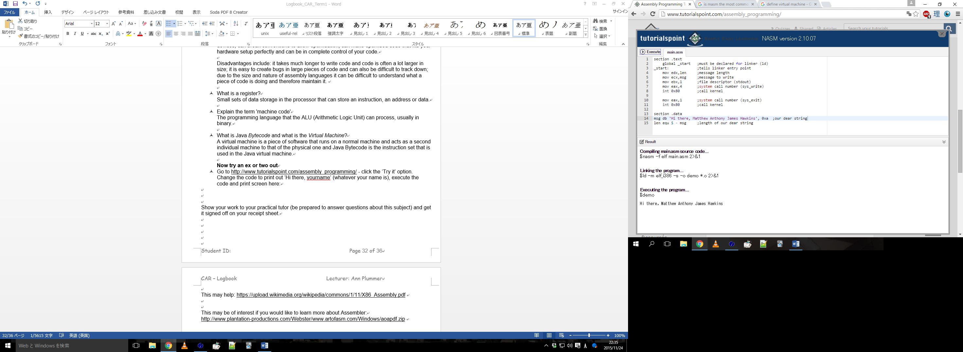Go to <http://www.tutorialspoint.com/assembly_programming/> - click the ‘Try it’ option. Change the code to print out ‘Hi there, yourname’ (whatever your name is), execute the code and print screen here:

Show your work to your practical tutor (be prepared to answer questions about this subject) and get it signed off on your receipt sheet.

This may help: <https://upload.wikimedia.org/wikipedia/commons/1/11/X86_Assembly.pdf>

This may be of interest if you would like to learn more about Assembler:

<http://www.plantation-productions.com/Webster/www.artofasm.com/Windows/aoapdf.zip>

# Topic: My Formative Test post mortem (term 1)

* Write down your score. What would your grade have been?

I got 53 which I don’t think is too bad, with more revision I can certainly get that up quite a bit. The grade would have been a PASS

* Are you on track for the grade you want in CAR? (0-39% is FAIL, 40%- 59% is PASS, 60%-69% is MERIT, 70%-100% is DISTINCTION)

I would like to get a merit so I need to revise

* Happy? Great – relax, you don't have much catch-up to do (unless you're easily pleased)
* Not so happy? Write down the areas you struggled most with and plan a catch up timetable between your Christmas celebrations.

Not sure as we didn’t get the results back, however, another exam was released on moodle which I will use to gauge my knowledge and plan a schedule.

You will be given Term 2 logbook exercises after Christmas.

*Please note that you will not be able to get any Term 2 signoffs*

*till you have the minimum number from Term 1.*

# Bibliography

# Checklist

Have you **completed EVERY exercise** in this term?

Yes

Have you obtained the minimum number of signoffs in your receipt sheet each term?

Yes

Have you passed your logbook? (it is not possible to retake this)